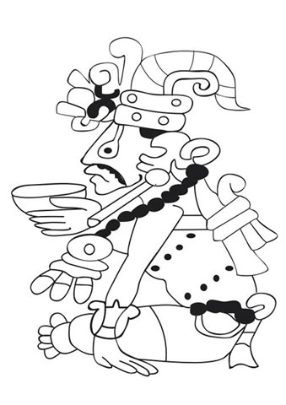
Ancient Civilizations
The Aztec, Incas, and Mayans

Write three sentences. Each sentence should have one new thing you learned about the Ancient Civilizations.

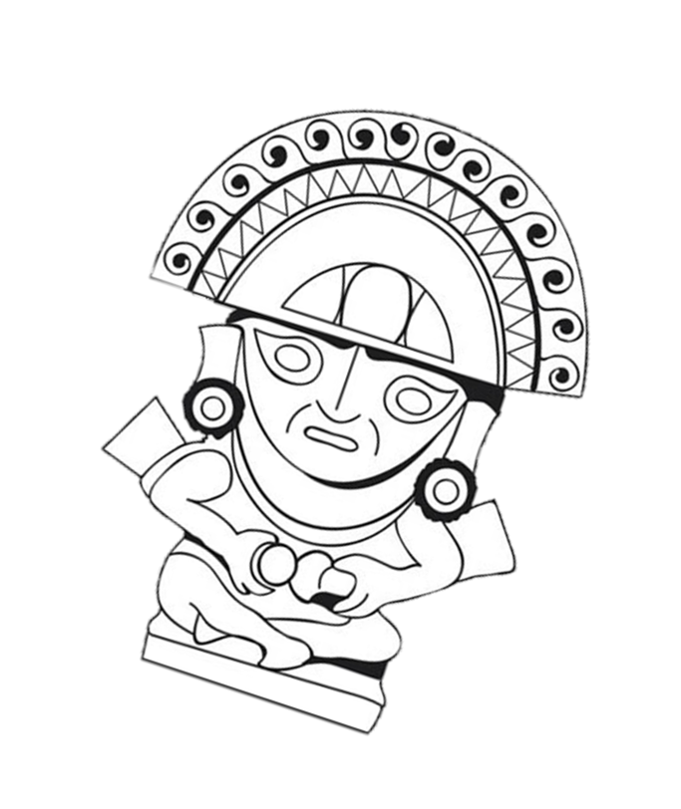
Use feathers and watercolor paints to decorate Viracocha just like the people of the Ancient Civilizations did!

