[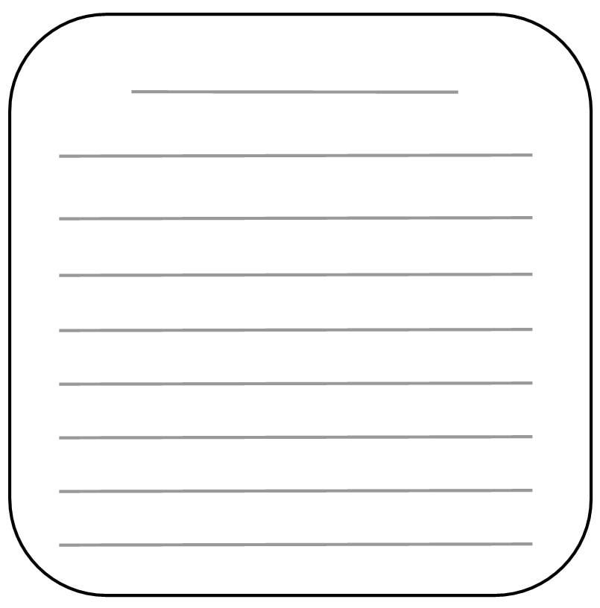](http://www.google.com/url?sa=i&rct=j&q=writing+lines&source=images&cd=&cad=rja&docid=rlctIdhElZ_PrM&tbnid=jMO83lydKP5FfM:&ved=0CAUQjRw&url=http://scrapbooking.about.com/od/freepatternsforembellishments/tp/7-Free-Shaped-Journaling-Boxes-With-Writing-Lines.htm&ei=qWVHUZinDpK10AGM54H4Ag&bvm=bv.43828540,d.dmg&psig=AFQjCNEQ5EF6WwcJpxjdEdQZCnHJ48zq8g&ust=1363719922371793)

[](http://www.google.com/url?sa=i&rct=j&q=writing+lines&source=images&cd=&cad=rja&docid=rlctIdhElZ_PrM&tbnid=jMO83lydKP5FfM:&ved=0CAUQjRw&url=http://scrapbooking.about.com/od/freepatternsforembellishments/tp/7-Free-Shaped-Journaling-Boxes-With-Writing-Lines.htm&ei=qWVHUZinDpK10AGM54H4Ag&bvm=bv.43828540,d.dmg&psig=AFQjCNEQ5EF6WwcJpxjdEdQZCnHJ48zq8g&ust=1363719922371793)[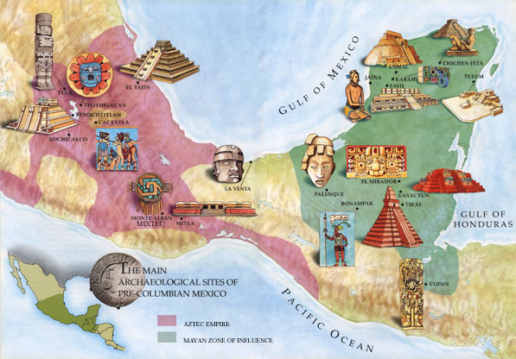](http://www.google.com/url?sa=i&rct=j&q=mesoamerica&source=images&cd=&cad=rja&docid=YvYfLjBgcHM8yM&tbnid=RuTZXmSqMifINM:&ved=0CAUQjRw&url=http://www.lib.uci.edu/about/publications/exhibits/meso/mesolandscape2.html&ei=cGRHUZ_TEOTx0wHJ6IGICQ&bvm=bv.43828540,d.dmg&psig=AFQjCNE5DkCSltD0ZFhH-vMW8GokagRiIQ&ust=1363719653128302)